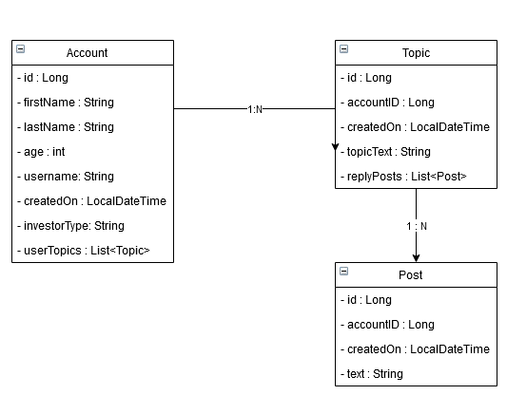

Select * From Post

Inner join user_account_created_posts cp on cp.id = post.id

Inner join user_account ua on ua.id = cp.id

DELETE: warning, if you do this all your posts will also be deleted, your topics will stay available for the public.